Mini Project Title

Submitted in partial fulfillment of the requirements of
Second Year in
Computer Engineering

By

Sujal Gaikwad (Roll No: 41)
Geet Ghadge (Roll No: 44)
Mayank Gawde (Roll No: 43)
Shravan Bhandare(Roll No.12)

Guide
Prof. Sushma Rathi


Department of Computer Engineering
DATTA MEGHE COLLEGE OF ENGINEERING,
AIROLI,NAVI MUMBAI -400 708
University of Mumbai
(AY 2025-26)

CERTIFICATE

This is to certify that the Mini Project 1B entitled “Smart Vaccination Record
Management System ” is a bonafide work of Sujal Gaikwad (Roll No:
41), Geet Ghadge (Roll No: 44), Mayank Gawde (Roll No: 43),
Shravan Bhandare (Roll No.12) submitted to the University of Mumbai in partial fulfillment of the requirement for the award of the degree of “Second year of Engineering” in “Computer Engineering”.

(Prof. Sushma Rathi)
Guide

(Dr. A. P. Pande) (Dr. P.A.Dode )
Head of Department Principal

Mini Project Approval

This Mini Project entitled“ Smart Vaccination Record Management
System ” by Sujal Gaikwad (Roll No: 41), Geet Ghadge (Roll No: 44), Mayank Gawde (Roll No: 43), Shravan Bhandare(Roll No.12) is approved for the degree of “Second year of Engineering” in “Computer
Engineering”.

Examiners

1………………………………………
(Internal Examiner Name & Sign)

2…………………………………………
(External Examiner name &Sign)

Date:
Place:

Contents

1 Introduction 1
1.1 Introduction
1.2 Motivation
1.3 Problem Statement and Objectives

2 Literature Survey 8

Abstract | i
List of Abbreviations | ii
List of Figures | iii
 | page no .
2.1 Survey of Existing System
2.2 Mini Project Contribution/ Objectives

3 Proposed System 16

3.1 Objectives of the proposed work
3.2 Architecture / Framework or Algorithm/process design
3.3 Details of Hardware and Software

- Implementation and Results 27

4.1 Results with Output

- Conclusion and Future work 33

Abstract

In today’s rapidly evolving digital era, maintaining accurate, secure, and easily accessible healthcare records has become essential for ensuring timely and effective medical care. Among various healthcare records, vaccination records play a crucial role in tracking immunization schedules, preventing the spread of infectious diseases, and ensuring the overall health and safety of children. Proper vaccination management is especially important during early childhood, where timely immunization can protect against life-threatening diseases. However, traditional paper-based vaccination systems often suffer from several limitations, including the loss or damage of records, difficulty in tracking schedules, and a general lack of awareness among parents regarding vaccination timelines and importance. The Digital Vaccination Record Management System is proposed as a modern solution to address these challenges by providing a centralized, efficient, and user-friendly digital platform for managing vaccination data. The system enables parents to securely register using mobile-based authentication and create profiles for their children by entering basic details such as name and date of birth. Based on this information, the system automatically generates a complete vaccination schedule aligned with standard immunization guidelines. Additionally, it provides timely reminders and alerts for upcoming, due, and missed vaccinations, ensuring that parents are always informed and can take necessary actions without delay.
The proposed system also focuses on enhancing user understanding by presenting medical information in a simplified and easy-to-comprehend format. Parents can access details about each vaccine, including its purpose, importance, and possible side effects, which helps in improving awareness and reducing confusion. Furthermore, the system ensures secure storage of vaccination records using a centralized database, allowing users to access their data anytime and from any device, thereby eliminating the risk of data loss and improving reliability.
By integrating automation, real-time notifications, and digital record management, the system significantly improves vaccination compliance and minimizes the chances of missed or delayed doses. It reduces dependency on manual tracking and enhances overall healthcare efficiency. This project aims to develop an intelligent, reliable, and parent-centric healthcare solution that not only simplifies vaccination management but also contributes to better preventive healthcare practices and improved public health outcomes.

I
List Of Abbreviations :
- OTP: One Time Password

- API: Application Programming Interface

- UI: User Interface

- UX: User Experience

- DB: Database

- CRUD: Create, Read, Update, Delete

- RBAC: Role-Based Access Control

II

List Of Figures:
- Fig 3.2 : Use Case Diagram
- Fig 3.3 : ER Diagram
- Fig 3.4 : Software Architecture
- Fig 3.5 :Deployment Diagram
- Fig 4.1 Login Page
- Fig 4.2 : User Dashboard
- Fig 4.3:Adding Child
- Fig 4.4: User Interface Live Map

III

1.Introduction
1.1 Introduction
The Digital Vaccination Record Management System automates vaccine information handling, with a user-friendly interface and quick data processing. The process of maintaining vaccination records for children has become an important part of preventive healthcare, public awareness, and timely immunization management. It can manage vaccination-related activities like child profile management, vaccine scheduling, record storage, notification handling, and tracking completed as well as pending doses. The main goal of this system is to organize and manage vaccination resources and schedules, making it easier for parents to monitor their child’s immunization journey while creating a simple and accessible user experience. It is a software application designed to automate and streamline the processes involved in managing digital vaccination records. It encompasses various functionalities aimed at efficiently managing child records, vaccine schedules, reminders, tracking, and administrative tasks. It serves as the backbone of a modern immunization support platform, enabling parents to focus more on the health and safety of their children rather than getting confused by manual records, missed dates, or complex vaccine names. By leveraging technology and automation, the system can adapt to the evolving needs of parents and maintain its relevance in the digital healthcare age. The Digital Vaccination Record Management System is designed to modernize the handling of child vaccination data by combining digital record management with smart reminder and tracking features. The system is developed using a modern web-stack environment, which provides a scalable and responsive application platform.
One of the main innovations in this project is the integration of a smart schedule generation engine, which allows parents to add a child profile by simply entering basic details such as the child’s name and date of birth. The system automatically retrieves and generates the child’s age-appropriate vaccination schedule based on the national immunization framework. This significantly reduces the time required to understand the schedule and minimizes errors in dose planning.
Another key feature is the intelligent vaccine timeline system, where each vaccine is represented in a structured digital schedule with due dates, status indicators, and reminder logic. Each child is assigned a personalized immunization roadmap corresponding to the vaccine timeline. When parents search or view a vaccine, they can see the exact due stage in the child’s schedule, similar to viewing events on a smart calendar dashboard.
The system also includes role-based access control, ensuring that parents can manage their children’s records securely while administrators can supervise data consistency and awareness features. By integrating automation, visualization, and efficient database management, the system aims to make vaccination tracking faster, easier, and more efficient.

1.2 Motivation
The main motivation for the creation of the “Digital Vaccination Record Management System” was the need for bridging the gap between static paper-based record keeping and dynamic parent interaction. In most homes and healthcare environments, the existing vaccination process is dependent on physical cards or fragmented records that act only as historical documents. The motivation was based on the need for a system that is not “passive,” but rather “proactive,” where the system actually helps the parent remember, understand, and act at the right time. The naming of the project as the “Digital Vaccination Record Management System” was based on the need for a new standard in the way child immunization records are stored, tracked, and understood.
Another of the major technical inspirations for the project came from the analysis of highperformance reminder and tracking platforms that are known for structured scheduling and user-friendly interfaces. The idea was inspired by systems that combine accurate data organization with clear visual guidance. The inspiration was to leverage these modern UI/UX philosophies used in professional-grade platforms—specifically the ease of understanding future actions through timelines and smart notifications—on the vaccination process itself. If a user can track appointments, deliveries, or deadlines through a digital platform with a single glance, a parent should be able to track a child’s upcoming vaccines with the same ease of visualization.
The project was motivated by the problem of Schedule-Awareness and Record Loss. In many households, parents waste time trying to decode vaccine names, due dates, and agebased dose intervals because the paper card does not provide sufficient clarity or timely assistance. The desire to eliminate this “healthcare friction” led us to develop our smart vaccine dashboard. Our vision was to develop a “Digital Immunization Companion,” where entering a date of birth does not simply produce a static list of vaccines but creates a guided schedule with alerts, completion tracking, and vaccine-specific awareness information. This would ensure that the parent’s journey from “Record Keeping” to “Timely Vaccination” is as efficient as possible.
The motivation for the project was also rooted in a desire to develop a high degree of Data Integrity and Automated Awareness. Inspired by structured, data-rich systems used in modern service platforms, we wanted to ensure that parent records remain protected from confusion, duplication, or missed reminders. This led us to develop our Reminder and Catch-Up Logic, which recalculates pending doses and suggests the next possible action when a vaccination is missed. By automating the reminder cycle using a scheduler-based engine, we were motivated to eliminate the burden of manually remembering every date and let the system handle the “memory work” itself, leaving the parents free to focus on the child’s health and wellbeing.

Gaps in the Domain:

1.2.1 The Physical-Digital Disconnect
The primary failure of existing systems is the “Visibility Gap.” While a record card may successfully indicate that a vaccine has been administered or is due, it fails to provide timely, digital, and user-friendly context. In child healthcare tracking, a handwritten or printed schedule is often insufficient for rapid understanding. Without a real-time visual representation of the child’s vaccination progress and upcoming due dates, parents spend an excessive amount of time checking dates, visiting healthcare providers for clarification, or unintentionally delaying doses, leading to a high “Missed Vaccination Risk” that discourages effective immunization compliance.

1.2.2 Data Integrity and Manual Record Fallibility
Parents and healthcare workers frequently face challenges during the record maintenance phase. Relying on paper-based cards or manually written vaccine entries—including complex vaccine names, multiple doses, and specific age windows—introduces a high risk of “Dirty Data.” Traditional systems do not have a built-in validation or correction mechanism. If an error is made during entry, it propagates through the child’s record, making the schedule confusing or incorrectly tracked. There is a distinct lack of automated reconciliation between stored child data and structured vaccination timelines.

1.2.3 Passive vs. Proactive Management
Existing vaccination record systems are fundamentally “Reactive.” They serve as passive repositories of data that only update when a parent or healthcare provider manually writes or checks something. For example, reminder action only begins after a date has already been missed, placing the entire burden of memory on the parent. There is no background “intelligence” or scheduling engine to monitor temporal data and provide proactive alerts. This lack of automation results in higher missed-dose rates and increased confusion for parents who must manually track and interpret due dates.

1.2.4 Scalability and Architectural Rigidity
Many legacy record systems are built on rigid manual structures that do not easily accommodate the dynamic nature of vaccination schedules, catch-up doses, or updated health guidelines. As the child grows or when special vaccination cases arise, updating the record often requires manual corrections rather than a simple automated schedule refresh. This lack of architectural flexibility prevents the system from evolving with real-world healthcare needs without breaking the continuity of the digital record.

1.3 Problem Statement
Despite the importance of vaccination in preventing diseases, the current systems used for managing vaccination records face several critical challenges. These challenges not only affect the efficiency of healthcare services but also impact the well-being of individuals, particularly children.
One of the primary problems is the reliance on paper-based vaccination records. These records are vulnerable to physical damage, loss, or misplacement. Once a vaccination card is lost, it becomes difficult to retrieve accurate information about previous vaccinations, leading to confusion and potential duplication or omission of doses.
Another major issue is the lack of a structured reminder system. Parents are required to manually keep track of vaccination schedules, which can be complex and span over several years. Without proper reminders, it is common for parents to forget vaccination dates, resulting in missed or delayed immunizations. This increases the risk of disease outbreaks and reduces the effectiveness of vaccination programs.
The lack of awareness and understanding of vaccination details is also a significant problem.
Many parents are not familiar with medical terms or the importance of specific vaccines. This lack of knowledge can lead to hesitation or negligence in following vaccination schedules.
Furthermore, there is no centralized system that allows easy access to vaccination records. Information is often scattered and not easily accessible when needed, such as during emergencies, travel, or school admissions. This creates inconvenience and delays in verification processes.
Additionally, traditional systems do not provide any guidance for missed vaccinations. If a vaccine is missed, parents are often unsure about the next steps, including when to reschedule the dose or how it affects the overall vaccination plan.
Therefore, there is a need for a digital, automated, and user-friendly system that can address these issues effectively. The system should provide secure storage, timely reminders, easy access to records, and simplified information to ensure complete and efficient vaccination management.

1.4 Aim and Objective of Research
Aim of this project is to eliminate the physical and digital inefficiencies found in traditional vaccination record handling by creating a synchronized, schedule-aware ecosystem. By integrating real-time vaccine tracking with automated reminder and catch-up logic, the system ensures that parents can monitor immunization progress instantly while maintaining a high-integrity digital record.
Hence, the research title is:
“Digital Vaccination Record Management System: A Smart Approach to
Immunization Tracking, Reminder Automation, and Parent-Centric Record
Management.”

Objectives
Objective 1: To develop a centralized parent dashboard that provides real-time oversight of vaccine status, upcoming due dates, completed doses, and overdue alerts.
Objective 2: To implement a smart schedule generation engine that automatically creates a child’s vaccination timeline based on the date of birth and age-specific immunization requirements.
Objective 3: To design a child profile management module allowing parents to dynamically create and update digital profiles for one or more children within the system.
Objective 4: To engineer a structured vaccine timeline interface using modern frontend technologies that provides a “One-View” progress perspective accessible on both mobile and desktop viewports.
Objective 5: To implement a vaccine reminder logic that triggers alerts at predefined intervals such as 7 days before, 3 days before, 1 day before, and on the due date itself.
Objective 6: To provide an instant-filter vaccine information system that allows parents to query the schedule by vaccine name, age group, or due status with quick response times.
Objective 7: To integrate a server-side scheduler-based engine that performs automated daily database scans for upcoming vaccine due dates and missed vaccinations.
Objective 8: To develop catch-up and missed-dose logic that identifies delayed vaccines and provides the next possible recommendation while pushing automated alerts to the user dashboard.
Objective 9: To enforce role-based access control (RBAC) using secure authentication and password encryption, ensuring that personal child records and parent data remain protected from unauthorized access.

1.5 Scope of Work
The scope of the Digital Vaccination Record Management System encompasses the design, development, and deployment of a full-stack web application tailored for parent-focused immunization tracking. The project aims to bridge the gap between health record storage and practical schedule awareness. The scope is categorized into three primary functional domains:

Scope 1: Parent Administration and Child Record Control
The administrative scope focuses on providing the parent with a high-integrity control center. This includes:
Digital Child Record Management: Full CRUD (Create, Read, Update, Delete) capabilities for child profiles, including date-of-birth-based schedule generation. Schedule Configuration: A module to define and update the child’s vaccine timeline, effectively creating a digital twin of the immunization journey.
Algorithmic Schedule Entry: Implementation of reminder and catch-up logic to validate status and ensure zero confusion in vaccine planning.
Dose Monitoring: Real-time tracking of completed, pending, missed, and overdue vaccines with automatic status calculations.

Scope 2: Parent-Facing Tracking and Discovery
The scope for the parent interface is centered on “Zero-Friction” accessibility:
One-View Interactive Timeline: Development of a responsive, structured vaccine progress view that allows parents to visualize the complete vaccination roadmap on any device. Precision Tracking: Implementation of intelligent status indicators that guide the parent to the exact upcoming or overdue dose.
Personalized Dashboard: A secure user portal where parents can view their child’s current vaccine status, due dates, and digital notification alerts.
Asynchronous Search: A high-speed search engine that provides instant filtering of vaccine information without page reloads.

Scope 3: Background Automation and Security
The technical scope includes the underlying engine that keeps the system “Proactive” and secure:
Automated Alert System: Integration of a server-side scheduling engine that performs daily database scans to identify vaccines due within the defined reminder window. Security Framework: Implementation of secure authentication and password hashing to ensure role-based access control, preventing unauthorized access to personal records. Cloud Integration: Deployment of the database and application on cloud-ready platforms to ensure high availability and 24/7 access.

1.6 Conclusion
The development of the Digital Vaccination Record Management System is a strategic move to address the increasingly complex record management processes within preventive child healthcare. By leveraging the power of integrating schedule-aware logic with backend automation processes, this project has managed to break away from the conventional barriers presented by paper-based and manually checked vaccination systems. The overall aim is to deliver a system where the “Schedule to Completion” process is optimized to its lowest possible delay while ensuring that the accuracy of the digital vaccination record is guaranteed through systematic control processes.
This project is not just about managing a record database; it is an exhaustive study in UserCentric Engineering. The integration of features such as the smart vaccine dashboard and the missed-dose catch-up logic is a clear indication of a decision-support architecture.
Inspired by modern structured tracking systems, this project has been built to deliver a “Zero-Friction” interface to users. This means that parents and administrative staff can now interact with vaccination records with unprecedented efficiency.
Ultimately, this project is a landmark achievement in building a parent-friendly health record ecosystem. By leveraging automation to manage the temporal process of due doses and by providing a clear digital representation of the child’s immunization path, this project has managed to directly address administrative confusion while empowering users. The subsequent chapters of this project will discuss the overall System Requirements,
Architectural Design, and Implementation of the algorithms that power this “Smart”

2. Literature Survey
2.1 Introduction

The literature survey is an important step in the creation of the Digital Vaccination Record Management System, as it offers a complete overview of existing methodologies that are being employed within child healthcare record management and immunization tracking. By analyzing various research papers, journals, and digital healthcare solutions, we can obtain a complete overview of the technological trajectory that has been followed by vaccination systems from manual card-based tracking to the use of cloud platforms and digital health record applications. The purpose of this literature survey is to compare our project to existing standards within healthcare technology and academia to ensure that we are overcoming the existing gaps within schedule awareness, missed-dose tracking, and parent usability that have affected vaccination record management for years.
In the past, vaccination management systems have been created primarily for “recordkeeping” rather than “guided parent interaction.” In fact, most of the initial digital vaccination systems that were created focused primarily on storing immunization history while completely disregarding the actual day-to-day experience of the parent. In this section of the project, we analyze existing digital health record systems and vaccination reminder platforms that are currently employed by various institutions and families. These range from basic hospital record software solutions to specialized immunization tracking applications. The purpose of this is to analyze whether a seamless integration is achieved between the digital record and the practical immunization journey of the child. In addition, we explore the “Design Philosophy” that is employed within existing reminder and tracking systems that are used for health-related scheduling. By referencing existing calendar, alert, and child-health support platforms, we explore how “schedule intelligence” is employed in health management and whether it can be repurposed into a more parent-centric vaccination ecosystem. The purpose of this is to justify why we are employing a structured vaccine timeline as well as a reminder and catch-up algorithm within our vaccination record management system. By completing this literature survey, we are able to obtain a complete overview of state-of-the-art vaccination management software that enables us to showcase the various innovations that we are making within our system that provide superior performance compared to existing record-based solutions.

2.2 Parent Administration and Child Record Control

The Parent Administration and Child Record Control module is designed to transition vaccination management from a passive documentation process to an active, guided workflow. Built using a backend system and a responsive parent portal, this module manages the entire lifecycle of a child’s immunization record—from initial profile creation and schedule generation to dose tracking and missed-vaccine handling. The core philosophy of this module is “Data Clarity,” ensuring that every child record is correctly structured and schedule-aware before it enters the production database.
Key Functional Components
1. Intelligent Child Profile Creation & Schedule Generation
Unlike traditional systems that accept manual records at face value, this module incorporates a smart schedule generation layer.
- The Process: When a parent enters the child’s name and date of birth, the system initiates an automatic timeline generation process. It calculates age-based vaccine stages while the parent fills in local details.
- The Logic: The schedule generation engine compares the child’s age with the vaccination timeline. If there is any mismatch or missing field, the system highlights the issue. • Result: This ensures that incomplete or confusing data is caught at the point of entry, maintaining a high-quality record that remains readable and useful for parents.
- Dynamic Vaccine Timeline Configuration
This component allows the parent or administrator to manage the “Digital
Immunization Journey.” • Timeline Mapping: Instead of static handwritten descriptions, the system uses a structured digital schedule to assign vaccine names, stages, and due dates to each child. • Schedule Synchronization: When a dose is completed, missed, or rescheduled, the system updates the timeline immediately across all views without requiring a manual rewrite.
- Dose Tracking & Lifecycle Management
The module provides a real-time ledger for all vaccination movements: • Vaccine Completion & Pending Doses: Tracks the administration date and calculates the expected due date of upcoming vaccines. • Missed-Dose Handling: Automatically assesses overdue vaccines based on the temporal delta if a vaccine is not marked complete by its recommended stage. • Status Flags: Manages the live status of vaccines (e.g., Upcoming, Due Soon, Due Today, Completed, Missed, or Overdue), which directly dictates the reminder intensity shown on the parent dashboard.

2.3 Parent-Facing Tracking and Discovery

This module is engineered using modern frontend technologies to provide a highly interactive, state-driven interface for parents. The core philosophy is to minimize the “Confusion-to-Action” time. While traditional systems stop at telling a parent whether a vaccine has been taken or not, this module uses a digital timeline approach to show exactly what is pending, what is upcoming, and what requires immediate action. By combining high-speed search with real-time schedule rendering, the system transforms vaccination tracking from a static paper process into an accessible digital health assistant.
Key Functional Components
- One-View Interactive Vaccine Timeline
The centerpiece of the parent experience is the structured vaccine progress view. • Visualization: The system renders a clear 2D dashboard-style timeline of the child’s immunization schedule. Instead of using scattered text entries, the timeline is built using dynamic components mapped to due dates and status conditions. • Responsiveness: Using modern layout technologies, the timeline scales across mobile, tablet, and desktop devices. This ensures that a parent outside the home has the same clarity on a smartphone as on a desktop system.
- The “View Vaccine Status” Precision Indicator
This is the practical application of the vaccine status logic. • The Reminder Logic: When a parent clicks a vaccine card, the system retrieves the corresponding due status and age stage.
• Visual Feedback: The frontend triggers a high-visibility status banner or highlighted card on the specific vaccine. This eliminates the need for the parent to interpret confusing handwritten schedules, as they can simply follow the dashboard action prompt.
3. Instant-Filter Search & Discovery
To handle real-time parent usage efficiently, the search engine is designed for speed. • Asynchronous Filtering: As the parent types in the search bar, the system filters the vaccine collection in real-time.
• Metadata Richness: Search results display not just the vaccine name, but also its due status, plain-language importance, and schedule relevance. If a vaccine is already completed, the system disables unnecessary reminder actions and shows completion details instead.

2.4 Background Automation and Security

This module is designed to handle the repetitive, time-sensitive, and safety-critical aspects of the system without requiring direct human intervention. While the other modules focus on user interaction, this module operates primarily on the server-side. It combines scheduler-based automation to manage vaccination timelines and industry-standard encryption to protect parent and child data. The goal is to move the system from a “Reactive” state (waiting for parents to act) to a “Proactive” state (acting on behalf of the parents), a transition that is essential for modern child healthcare support.
Key Functional Components
1. Proactive Temporal Scheduling Engine
This is the automated “Brain” of the system that manages deadlines. • Autonomous Scanning: Using a scheduler library, the system wakes up at a specified time every day (e.g., 8:00 AM) to scan the vaccination records in the database. • The Reminder Logic: The scheduling algorithm identifies any vaccine that is exactly within the next reminder threshold such as 7 days, 3 days, 1 day, or due today. • Automated Notification: Once identified, the system automatically pushes a notification to the specific parent dashboard. This proactive approach significantly reduces missed doses and ensures healthier vaccine compliance.
Implementation Syntax (PTSA):
Server-side implementation of the reminder alert logic const cron = require('node-cron');

cron.schedule('0 8 * * *', async () => { const today = new Date(); const childProfiles = await Child.find({});

childProfiles.forEach(async (child) => { child.vaccines.forEach(async (dose) => { const dueDate = new Date(dose.dueDate); const diff = Math.ceil((dueDate - today) / (1000 * 60 * 60 * 24));

if (diff <= 7 && diff >= 0 && dose.status !== 'Completed') { await Parent.findByIdAndUpdate(child.parentId, {
$push: { notifications: { message: "Reminder: Vaccine due soon.", type: "Alert" } }
});
}
});
});
});

2. Role-Based Access Control (RBAC)
To maintain the integrity of the digital vaccination record, security must be strictly enforced.
- Token-Based Authentication: We implemented secure authentication. When a user logs in, the server generates an encrypted token that contains their identity and role.
- Route Protection: This token is required for every protected action. For example, schedule-editing tools and administrative record controls are locked behind an authorized-access gate. If an unauthorized user tries to access these routes, the system rejects the request immediately.
Implementation Syntax (RBAC Middleware): const checkAuthorizedRole = (req, res, next) => { const token = req.headers['authorization']; const decoded = jwt.verify(token, process.env.JWT_SECRET);

if (!decoded.role) { return res.status(403).send("Access Denied: Authorized Role Required");
} next();
};
3. Data Encryption & Integrity
- Password Hashing: Parent and admin passwords are never stored in plain text. We use hashing, which ensures that even if the database were compromised, the actual passwords remain unreadable.
- Secure API Communication: All data transferred between the frontend and backend is handled through secure channels, ensuring that sensitive information like child identity or vaccine records cannot be intercepted.
Implementation Syntax (Password Hashing):
const bcrypt = require('bcrypt');

userSchema.pre('save', async function(next) {
if (this.isModified('password')) { const salt = await bcrypt.genSalt(10); this.password = await bcrypt.hash(this.password, salt);
} next();
});

2.5 Language Used

JavaScript
Serves as the core language for both the frontend and backend, creating a unified development environment. Reduces system cognitive load and ensures data type consistency, which prevents
“Dirty Data” issues often found in multi-language stacks. Powers reminder logic by handling complex workflow conditions and asynchronous operations simultaneously.
Purpose:
Serves as the core language for both the frontend and backend, creating a unified development environment. It reduces system complexity and ensures data type consistency, preventing issues like dirty data. It also powers complex logic such as reminder generation and asynchronous API handling.
Usage in Program: Used for implementing core application logic, handling asynchronous operations, and managing communication between frontend and backend.
Syntax:
const generateSchedule = async (dob) => { const vaccinePlan = getVaccinationPlan(dob); const userInput = getFormInput(); if (!vaccinePlan || !userInput.childName) { setValidationFlag(true);
}
};
React.js (Frontend Framework)
Used to build an asynchronous Single-Page Application (SPA), moving away from slow, refresh-heavy legacy systems. Enables instant rendering of vaccination timeline data, allowing the schedule to update without a page reload. Utilizes the virtual DOM to manage reminder banners and real-time vaccine filtering. Purpose:
Used to build an asynchronous Single-Page Application, eliminating the need for constant page reloads. It enables fast rendering of UI components and efficient updates using the virtual DOM.
Usage in Program: Used to create the user interface, implement real-time updates of the vaccination timeline, and manage dynamic features like search filtering and notifications.
Syntax: const VaccineCard = ({ vaccine, active }) => { return (
<div className={active ? "highlight-card" : "normal-card"}>
<h3>{vaccine.name}</h3>
<p>{vaccine.status}</p>
</div>
);
};
Node.js & Express.js (Backend Environment)
Provides a high-concurrency, event-driven environment necessary for real-time data synchronization.
Executes the scheduling engine in the background, ensuring background tasks do not interrupt the parent’s user flow. Manages secure API routing and handles the communication bridge between the UI and the database.
Purpose:
Provides a scalable, event-driven backend environment for handling multiple requests efficiently. It supports background processing and API management.
Usage in Program: Used to handle server-side logic, manage API routes, execute background tasks, and connect the frontend with the database securely.
Syntax: const cron = require('node-cron');

cron.schedule('0 8 * * *', async () => {
const upcomingVaccines = await VaccineRecord.find({
dueDate: { $lte: new Date(Date.now() + 7 * 24 * 60 * 60 * 1000) }
});
});
MongoDB (NoSQL Database)
Selected over traditional SQL systems for its schema-less versatility, which is essential for flexible child records and immunization schedules. Stores child profiles, vaccine schedules, and notification data as flexible JSON-like documents.
Allows the digital vaccination record structure to be modified in real-time as new data is added or updated.
Purpose:
A flexible, schema-less database used to store data in JSON-like format. It allows easy modification of data structures as requirements evolve.
Usage in Program: Used to store child data, vaccine schedules, notification records, and parent information, enabling real-time updates and efficient data retrieval.
Syntax:
const ChildSchema = new mongoose.Schema({ childName: { type: String, required: true }, dob: { type: Date, required: true }, vaccines: [{ vaccineName: String, dueDate: Date, status: String
}]
});

2.6 Conclusion

The Literature Review section of this chapter has outlined a roadmap for the evolution of vaccination record management technology. By analyzing existing models from paper cards to digital health support systems, it is obvious that while data storage has improved, user guidance has not improved as significantly. The “Record-Awareness Gap” is a phenomenon that is brought up by this research as a problem that has yet to be fully addressed. The medical schedule of a child and the actual parent understanding of that schedule are two separate worlds that have yet to be fully integrated. And it is this gap that has caused parents, even within a digitally connected environment, to face a very real problem when tracking vaccinations.
Moreover, by analyzing existing solutions and reminder-based platforms, it has become obvious that “Smart” means one thing: algorithmic intelligence is what is necessary for a vaccination record system to be a true efficiency tool for parents. The absence of catch-up tools and background reminder engines within existing record systems is a glaring problem that represents a true usability oversight. The absence of proactive logic and user-friendly visualization is what has become the primary motivation for this project’s implementation to ensure that the Digital Vaccination Record Management System is more than simply a digital card. In other words, it is a decision-support tool. The literature has outlined a very clear path forward for vaccination record technology: a future where asynchronous stateful applications are the only way to ensure that immunization records are managed effectively. By utilizing a modern full-stack approach along with specialized reminder and tracking logic to ensure data clarity, this project has directly addressed the inefficiencies outlined by the survey. While this chapter has outlined a path forward by establishing a benchmark for what is possible, it is time to shift gears from theory into system requirements specification and system design methodology itself

3.Proposed System framework
3.1 Introduction

The Digital Vaccination Record Management System is built as a decoupled, full-stack architecture based on modern web technologies. Instead of being a monolithic application itself, it is built as a digital companion to the real-world child immunization journey. Its architecture is based on asynchronous data flow to ensure that the user interface remains fast and responsive even while running computationally intensive tasks such as proactive reminder scheduling for due vaccines. By decoupling the frontend from the backend, the application scales and runs faster to meet the real-time requirements of modern parent-facing healthcare support.
At its core, the Digital Vaccination Record Management System is built on a decisionsupport layer that leverages various specialized algorithms to manage schedule data. The front-end is built to provide a frictionless experience. It communicates with the backend through a secure REST API to fetch live data for displaying on the vaccine timeline. As soon as a parent marks a vaccine as completed or an admin updates schedule information, the change is propagated live to all active views. This live update is essentially the beating heart of the framework and makes the path from a digital reminder to actual vaccination action much smoother.
On the other hand, the back-end is built with data integrity and automated maintenance in mind. MongoDB is used to store data in a document-based structure that can be easily adapted to changing child records, vaccine histories, and notification logs without being locked into a predefined table structure. This is also where the reminder logic and catch-up handling are implemented as intelligent filters over vaccine schedule data. With a secure authentication layer and server-side scheduler jobs, not only is the proposed system modern and sleek, but it is also architecturally secure and proactively managed to address gaps in existing vaccination record management systems.

3.2 Proposed System

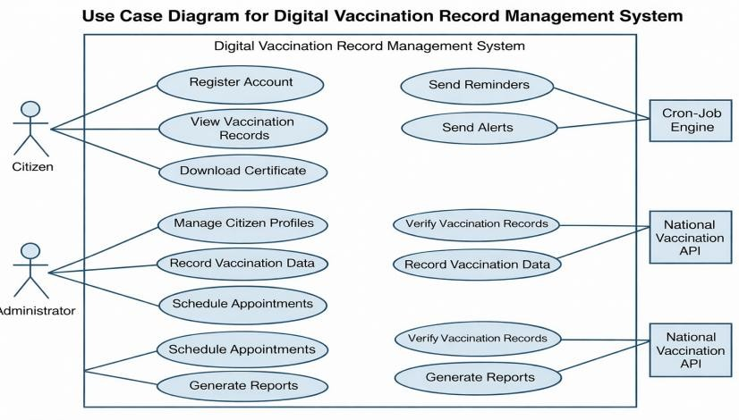
Fig 3.2 : Use Case Diagram
The Use Case Diagram defines the functional scope of the Digital Vaccination Record Management System by illustrating the interactions between external actors and the internal system processes. Unlike traditional health record systems, this system identifies both human actors (Parents and Administrators) and automated system actors (Scheduler Engine). The boundary box represents the encapsulated application environment, ensuring that all interactions are governed by the system’s core logic and security protocols.
The diagram is bifurcated into user-driven interactions and system-driven automation to highlight the proactive nature of the framework:
- Parent (Primary Actor): The parent interacts with the system for tracking and schedule monitoring. Key use cases include Add Child Profile, View Vaccine Schedule, Search Vaccine, and Mark Vaccine Status. The parent also acts as a recipient for reminder alerts, a proactive feature designed to reduce missed doses. • Administrator (Primary Actor): The admin holds elevated permissions for system maintenance. They are responsible for managing vaccine records, monitoring users, and maintaining awareness content. A critical use case is supervising the consistency of digital records and schedule logic. • Scheduler Engine (Secondary Actor): This represents the background automation layer. It autonomously triggers the scan-due-dates and generate notifications use cases. By including this as an actor, the system demonstrates proactive intelligence, operating even when no human users are logged in.

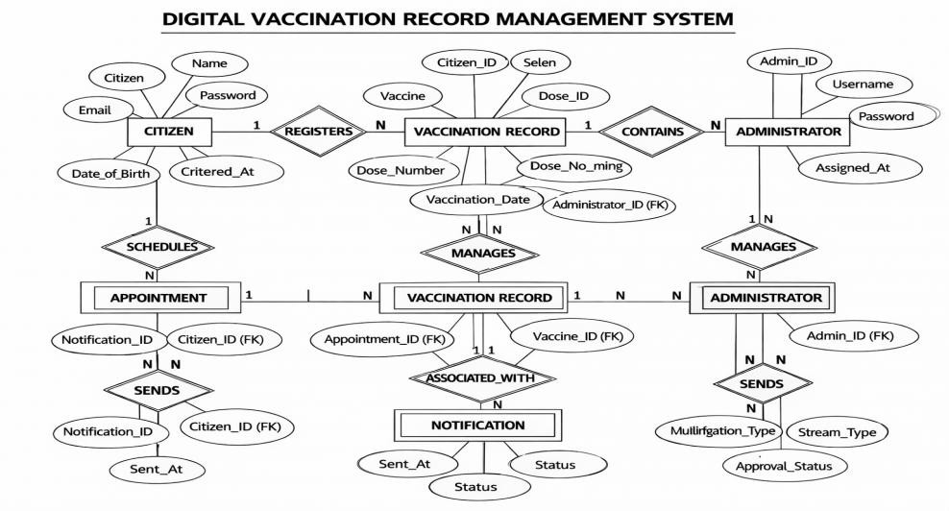
Fig 3.3 : ER Diagram

The ER Diagram for the Digital Vaccination Record Management System illustrates the logical schema and data associations within the database environment. Unlike traditional flat-file systems, this schema uses a combination of primary entities and specialized collections to support schedule generation, reminder automation, and record tracking.
Core Entities and Attributes
- USER: This entity stores essential profile data, including User_ID, Email, Role, and Password. The Role attribute is critical for enforcing role-based access control.
- CHILDPROFILE: Serves as the central repository for child data, including Child_ID,
Child_Name, Date_of_Birth, Gender, and Parent_ID.
- VACCINERECORD: Captures the real-time lifecycle of each vaccine. It acts as a bridge between the child and the vaccine schedule, storing Record_ID, Due_Date,
Status, and Completion_Date.
- NOTIFICATION: Maintains reminder records generated by the automated engine. • VACCINEINFO: Stores vaccine metadata including vaccine name, disease prevented, age group, and description.
Relationship Mapping and Logic
- USER to CHILDPROFILE (1:N): One parent can manage multiple child profiles. • CHILDPROFILE to VACCINERECORD (1:N): One child can have multiple vaccination records throughout the immunization journey.
- USER to NOTIFICATION (1:N): One user can receive multiple proactive alerts. This relationship is driven by the scheduling engine, which creates notification objects when vaccine deadlines fall within the reminder window. • VACCINERECORD to VACCINEINFO (N:1): Each vaccine record corresponds to a predefined vaccine information object that stores descriptive and educational details. • HISTORY: This entity maintains the long-term records of all completed vaccines, allowing the system to track dose completion trends and missed-dose patterns over time.
Frontend and Backend Orchestration
The logic layer is essentially the central traffic manager that integrates all the RESTful API endpoints, effectively connecting the user interface and the database. When a parent performs a vaccine search, the server processes the request and runs the schedule mapping logic, retrieving the exact due status, age stage, and timeline position from the database. At the same time, security is maintained through authenticated access, allowing only authorized personnel to access sensitive admin functions and personal child records

Background Service and Data Integration

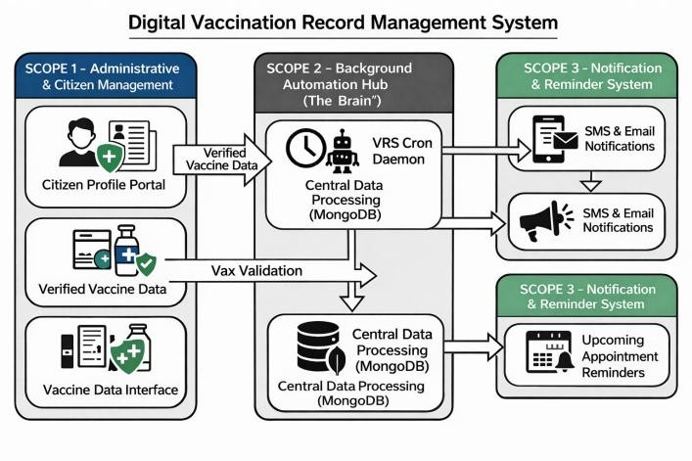

Fig 3.4 Software Architecture

The most interesting feature of this architecture is that it has a background service layer that operates independently from the main request and response process. This layer has integrated the proactive scheduling engine, which uses a scheduler and operates like a daemon that runs every day, scanning the vaccine records collection for upcoming due dates. This essentially means that the system is proactive and can send notifications directly to the parent dashboard without any manual trigger. Moreover, there is also an educational information layer that can support child-vaccine awareness, enabling the parent to understand what each vaccine is for and why it is important.
Software Architecture
Scope 1: Parent Administration & Child Record Control (The Input Phase)
This is the starting point of all data within the system.
- Child Profile Registration Portal: Instead of manually maintaining every detail on paper, the parent enters child information. This triggers the schedule generation engine, where the system builds an age-based vaccine plan while the parent provides local context. • Vaccine Timeline Configuration Tool: This allows the parent or admin to define the digital twin of the child’s vaccination journey.
- Reminder Logic Processing: This is the first algorithmic gate. The reminder and catch-up logic checks the due schedule and missed-dose states before data is saved or updated.
Scope 2: Parent Tracking & Schedule Monitoring (The Output Phase)
This is the “Zero-Friction” interface where the parent interacts with the results of the backend logic. • Instant-Filter Vaccine Search Engine: As a parent types, the system filters the vaccine collection in real-time, showing only relevant results with quick response times. • One-View Vaccine Timeline: This is the visual progress layout of the child’s immunization journey. It does not perform the calculations itself; it just displays what the backend tells it to.
- Reminder Highlights: When a vaccine becomes due, the system triggers a visual alert at the exact timeline stage calculated by the backend. This eliminates the need for parents to decode difficult schedule patterns.
Scope 3: Background Automation Hub (The “Brain”)
This module sits in the center because it manages the system’s memory and intelligence without needing a human to click anything. • Central Data Repository (MongoDB): This is the local storage for all child records, vaccine timelines, and notification logs. • Scheduling Daemon: This is the automated background timer. Every day at a fixed time, it wakes up to calculate the temporal delta—the time left until a vaccine is due.
- Data Outputs (Connections): o Push Notifications: If a vaccine is due within the reminder threshold, the brain pushes an alert directly to the parent dashboard.
o Status Flags & Schedule Updates: It sends live data such as “Upcoming,” “Due Soon,” or “Missed” to the tracking layer.

3.3 Data Structure and Algorithm Design

The system utilizes a NoSQL document-based data structure, which is more malleable and efficient than old-school table-based data structures. This data structure is well suited to the flexible and evolving nature of child vaccination schedules, where some children may have standard dose progression and others may need catch-up recommendations. We represent the vaccination record system as a set of nested objects in our digital data structure.
Data related to individual child profiles (profile structure): Each individual child is represented as its own document, containing nested vaccine schedule objects. This allows us to retrieve all required tracking data for a given child through a single database query, minimizing latency.
Data related to individual vaccine records (temporal structure): In order to drive our proactive notification engine, we represent individual vaccine records as standardized date objects. This allows us to accurately calculate reminder offsets and missed-dose logic without running into invalid date issues.
The system is based on three algorithms that control the direction of actions, ensure record integrity, and manage background processes with minimal stress.

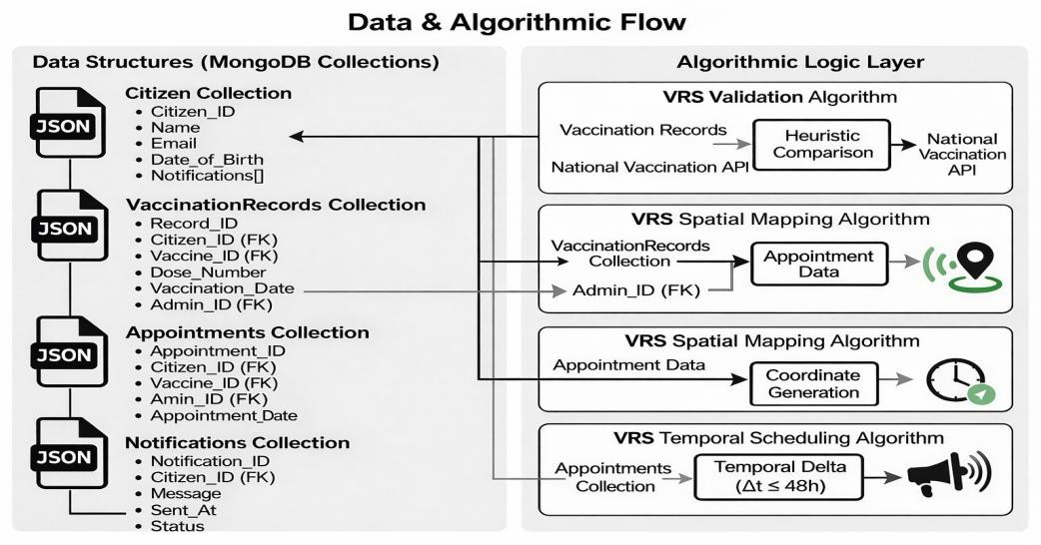

Fig 3.5 Deployment Diagram

1. Vaccine Schedule Mapping Algorithm
2.
This algorithm is responsible for real-time spotting of pending and completed vaccines through the use of relative date rendering. The following are the steps: Step 1: The algorithm takes a Child_ID as an input and retrieves the corresponding vaccine list and status records from the database.
Step 2: It retrieves the corresponding due dates and stage details for each vaccine. Step 3: It sends the schedule information to the frontend, where it is converted into a visible timeline position based on the child’s age and due sequence. Step 4: It initiates a highlighted status display at the correct stage, directing the parent’s attention directly at the required action.
Algorithm:
INPUT: child_id
OUTPUT: Visual highlight on UI timeline
START
- Receive Child_ID from user dashboard.
- Retrieve child details from database using Child_ID.
- Extract vaccine schedule associated with the child.
- Retrieve due dates and statuses from vaccine record database.
- IF schedule data exists THEN
  - Convert dates into display sequence.
  - Mark the current stage on the timeline interface.
  - Highlight the next required action for the user.
ELSE
Display message “Vaccination information not available”.
- END IF
END

2. Multi-Stage Reminder and Catch-Up Logic
This is a comparison and decision engine that filters due records and prevents missed doses from being ignored. It works with both due date data and current date conditions.
The following are the steps: The system sets the alert flag as true if the current date approaches the due date according to reminder thresholds. The system performs a temporal comparison between present time and stored due dates and generates reminder or catch-up recommendations.
Algorithm:
INPUT: child_vaccine_record
OUTPUT: alert_flag, recommendation_data START
- Accept child vaccine record from database.
- Retrieve due date for each vaccine.
- Compare due date with current system date.
- FOR each vaccine
IF reminder threshold matches THEN Generate alert message.
Suggest next action.
END IF
- IF vaccine is already completed THEN Mark as completed entry.
ELSE
Ask parent to confirm completion or reschedule.
- Save final updated status in database.
END

3. Proactive Temporal Scheduling Algorithm
This is a server-side background batch processing engine that runs a scan of all active vaccine records. It is set to run once a day at a fixed time. The following are the steps: The algorithm calculates time remaining = Due_Date – Current_Date and determines if the value is less than or equal to the reminder threshold.
The system creates a new notification object on the user dashboard.
Algorithm:
INPUT: current_system_time
OUTPUT: notification_payloads to user dashboards
START
- Fetch all active vaccine records from database.
- FOR each record
  - Retrieve Due_Date.
  - Calculate Time_Remaining = Due_Date - Current_Date.
  - IF Time_Remaining <= reminder threshold THEN Generate reminder notification.
Send notification to user.
END IF
- Repeat process at scheduled time every day. END

3.4 Deployment Environment

The project is based on a modern full-stack technology stack due to its capabilities in handling asynchronous tasks and rendering the vaccination dashboard dynamically. The system was developed and tested using the following environment: • Hardware: Standard Laptop/PC (Intel Core i5 or above, 8GB RAM or above).
    - Operating System: Windows 10/11.
    - Code Editor: Visual Studio Code (VS Code).
    - Version Control: Git & GitHub for collaborative tracking. • API Testing: Postman for validating the schedule generation and reminder endpoints. Frontend:
The project will be developed using React.js version 18.0 and above for rendering the dashboard and vaccine timeline through reusable components.

Backend:
The project will be developed using Node.js version 18.x and above for handling nonblocking I/O and background scheduler jobs.
The project will be developed using Express.js as a web framework for routing the RESTful API.

The project will be developed using MongoDB Atlas version 6.0 and above as a cloud-hosted NoSQL database for flexible JSON data types for storing child profiles, vaccine records, and notification data.

The project will be developed using the following development tools:
- Visual Studio Code as the primary integrated development environment
- Postman for API testing and debugging
- Git and GitHub for version control and CI/CD pipelines

Deployment Design Pattern
The Digital Vaccination Record Management System uses a decoupled client-server setup. It means the view layer uses React.js, the logic layer uses Node.js with Express.js, and the data layer uses MongoDB. With an asynchronous and non-blocking setup, the system can process multiple requests at a time—like multiple parents checking schedules while administrators update vaccine information—without compromising performance. This setup caters to the need of the timeline and reminder logic, which requires real-time communication between the frontend and database to display current vaccination status and alerts.

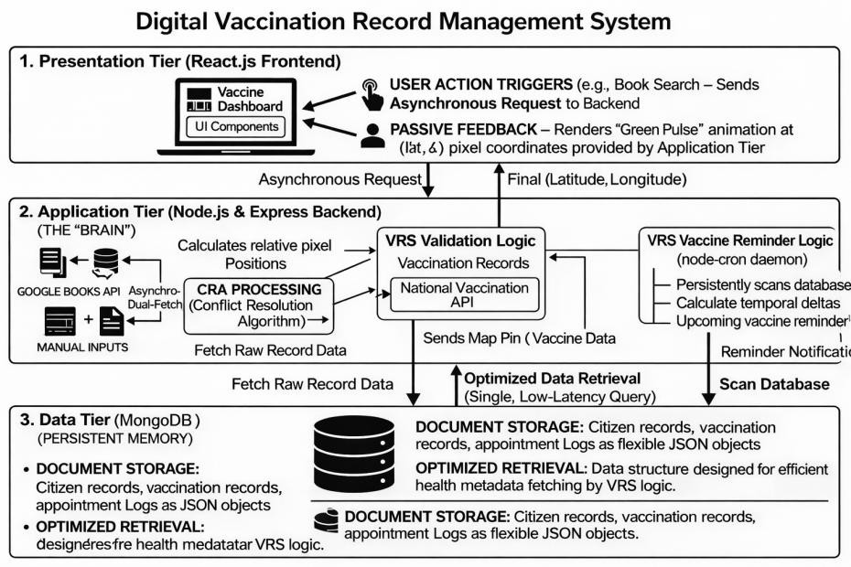
Fig 3.4 Deployment Diagram

1. Presentation Tier (The User Interface)
This is the face of the application. It is the only part of the system the end-users actually see and interact with. Its main job is to display information and capture user inputs. • HTML/CSS: This forms the skeleton and styling of the web pages. It defines where the child profile form goes, how the dashboard looks, and the colors of the reminder indicators.
- JavaScript: This acts as the bridge between the user’s screen and the backend server. When a parent adds a child and clicks save, JavaScript catches that click, packages the request into JSON, and sends it to the application tier.
- The Views: Parent Portal: A clean, restricted view where parents can add child details, look at the digital vaccine schedule, track upcoming or missed doses, and check notifications. Admin Dashboard: A secured, privileged view where administrators can manage vaccine data, user records, and awareness information.
2. Application Tier (The Backend Logic)
This is the brain of the system. It sits safely behind the scenes, processing rules, making decisions, and moving data around.
- Node.js & Express.js: Node.js is the engine, and Express.js is the framework that organizes the code. Express.js sets up the API endpoints—secure doorways that listen for JavaScript requests coming from the presentation tier. • The Services (Business Logic):
Schedule Service: Handles vaccine timeline generation. User Service: Verifies login credentials and ensures parents cannot access admin-only pages.
Notification Service: Takes the raw due dates from the database and packages them into reminder alerts for the frontend.
Tracking Service: Enforces the application’s health tracking logic. If a parent checks the dashboard, this service verifies whether vaccines are upcoming, due, completed, or missed.
- Scheduler Engine: This is a background timer built into the backend app. Once a day, it wakes up, scans the database for vaccines due soon, and automatically fires dashboard alerts to the parents.
3. Data Tier (The Database)
This is the memory of the system. If the server crashes and restarts, this tier ensures no data is lost.
- MongoDB: A document-based database. The application tier talks to MongoDB using Mongoose, which translates JavaScript objects into structured database documents.
- Database Schema (Collections):
Users: Stores parent and admin profiles. ChildProfiles: Stores child records including name, date of birth, and linked parent information.
VaccineRecords: The transaction-like log linking a child to each vaccine stage.
Notifications: Stores generated reminder alerts and awareness messages.
Hardware Requirements for Server & Client Side
To ensure that the dashboard and reminder engine are executed within a quick response time, the following hardware requirements are set for the project:
Operating Systems: Windows 10/11, macOS, or Linux
Browser Tools: Google Chrome, Mozilla Firefox, Microsoft Edge
Programming Languages: JavaScript, HTML5, CSS3, Node.js, Express.js, BSON/JSON Data Format, Mongoose ODM

3.5 Conclusion

The proposed framework for the Digital Vaccination Record Management System represents a significant shift from static, record-keeping health logs toward an interactive, proactive digital healthcare support ecosystem. By moving away from synchronous, refresh-heavy legacy architectures and adopting an asynchronous single-page application, the system achieves the high-concurrency performance required for real-time parent use. The integration of a decoupled architecture ensures that the frontend tracking tools and the backend reminder engines function independently, providing a seamless experience that mirrors the efficiency of modern scheduling platforms.
Central to this framework is the transition from reactive data handling to proactive algorithmic intelligence. The implementation of the reminder and catch-up logic ensures that the clarity of the vaccination record is maintained through intelligent schedule evaluation, effectively reducing the risk of missed-dose negligence during tracking. Simultaneously, the vaccine schedule mapping logic bridges the record-awareness gap, transforming raw due-date data into a visual navigation aid that reduces the time spent understanding vaccination progress. This dual focus on data integrity and user-centric tracking addresses the primary operational problems that have historically affected traditional vaccination record systems.
In summary, the proposed system framework provides a scalable, secure, and highly flexible solution that is uniquely suited for the dynamic needs of modern child healthcare record management. By utilizing NoSQL database structures for flexible profile storage and scheduler-based automation for proactive management, the system moves beyond being a simple record tool to becoming an active decision-making asset. This concludes the theoretical and architectural design phase of the project, establishing the technical foundation for the detailed implementation and testing phases that follow

4. Implementation and Results
4.1 Introduction

The implementation phase of the Digital Vaccination Record Management System represents the transition from theoretical architectural design to a fully functional, high-performance software ecosystem. The primary objective of this phase was to successfully realize the parent-centric digital record concept by integrating a responsive frontend interface with a robust backend system and a flexible, scalable data storage solution. This phase focuses not only on building the system but also on ensuring that all components work seamlessly together to provide a smooth user experience. This chapter provides a detailed description of the technical environment used for development, the systematic implementation of the core algorithms, and the configuration of a secure and cloud-ready infrastructure for reliable deployment.
By adhering to modern full-stack development principles, the implementation emphasizes asynchronous data flow and real-time synchronization between system components. Unlike traditional record management systems that rely heavily on manual verification, repeated navigation, and delayed updates, the proposed system adopts a single-page application (SPA) approach. This ensures that vaccination schedule updates, dashboard changes, and vaccine filtering operations are performed instantly without requiring page reloads. This significantly enhances system responsiveness and user interaction. Special attention was given to optimizing the reminder logic and vaccine tracking algorithms so that they are not only functionally accurate but also efficient in terms of execution speed, ensuring low-latency performance suitable for real-world usage by parents. Additionally, the system implementation incorporates secure authentication mechanisms, efficient database handling, and well-structured API communication between the frontend and backend layers. The use of modular coding practices ensures that the system remains scalable and maintainable for future enhancements. Error handling and validation techniques were also implemented to ensure data integrity and reliability during user interactions.
The results of this implementation clearly demonstrate that shifting from a reactive system to a proactive system has a significant and measurable impact on vaccination management. The system effectively identifies upcoming, due, and missed vaccinations through intelligent dashboard alerts and notification mechanisms. This proactive approach reduces dependency on user memory and minimizes the chances of missed vaccinations. Furthermore, the system simplifies schedule tracking by presenting clear, structured, and easy-to-understand information, thereby reducing confusion among users.
By evaluating system performance under practical usage conditions, it is evident that the implemented architecture is capable of handling real-world demands efficiently. The integration of secure authentication layers, along with a cloud-hosted database, ensures that user data remains protected while maintaining high availability and fast access. The system performs reliably without compromising speed, responsiveness, or data integrity, making it a suitable solution for modern digital healthcare record management.
4.2 Implementation

4.2.1 Overview of the Technical Stack
The implementation of the Digital Vaccination Record Management System is based on a modern full-stack architecture that facilitates the development of high-concurrency, real-time applications. By utilizing Node.js for the runtime environment and React.js for the user interface, we ensured a seamless data flow from the parent management backend to the child vaccination dashboard.

Security & Session Management
We implemented secure authentication for communication. Upon a successful login, the server generates a signed token containing the user’s role. This token is stored securely and sent in the header of every API request. This ensures that only an authorized user can access protected child records or modify sensitive data.

Security & Role-Based Access
The system implements role-based authentication for secure access. • Admin Security: Additional validation logic was implemented on the registration page to ensure only authorized personnel can access the admin panel. • Protected Routes: Routing protection was used to prevent parents from accessing internal management tools.

Vaccine Schedule Mapping Implementation
The vaccine tracking algorithm was implemented using a date-based rendering system.
• Backend: MongoDB stores due dates, status values, and vaccine metadata for each child. • Frontend: Custom logic calculates the display position relative to the dashboard and highlights the current vaccine stage. The reminder effect was achieved using dynamic status rendering triggered when a vaccine’s due date matches the schedule logic.

Data Integrity & Reminder Logic
The reminder and catch-up logic was implemented using backend comparison functions and asynchronous operations.
• When a child profile is created, the system triggers a schedule generation process. • The system then compares the current date with each due stage. Any approaching or overdue vaccine triggers a visible alert on the dashboard.

Proactive Automation
The proactive scheduling algorithm was implemented using a scheduler package.
• A background process is scheduled to run daily. • It performs a temporal delta calculation by comparing the dueDate of all active vaccine records against the current date. • If the difference falls within the reminder threshold, the system generates a notification object and pushes it to the parent’s dashboard notifications array.

4.3 Results with Output
The entry point for all users is the unified authentication portal, which ensures secure access to the system through role-based access control.
- Parent Registration: The interface is streamlined for zero-friction onboarding, requiring a unique username and verified email. This links the user to the reminder engine for future due alerts.
- Administrator Security: For administrative roles, the system dynamically renders an authorized-access validation field. This critical security layer ensures that only verified personnel can access the high-level management tools.

1. Login Pages
The login and registration pages provide the gateway to the application. The parent registration flow is streamlined for simple onboarding. To ensure data privacy, the system requires a unique username and a verified email address. This interface acts as the initial data ingestion point for the user collection in the database, which later facilitates the proactive scheduling algorithm by linking the parent account to automated vaccine due alerts.
The administrator registration includes an additional security layer. This is a critical implementation of the system’s security protocol. The extra validation field is dynamically rendered only when the admin role is selected, preventing unauthorized access to backend management tools. This ensures that only verified personnel can access dashboard control features and system-level record supervision.

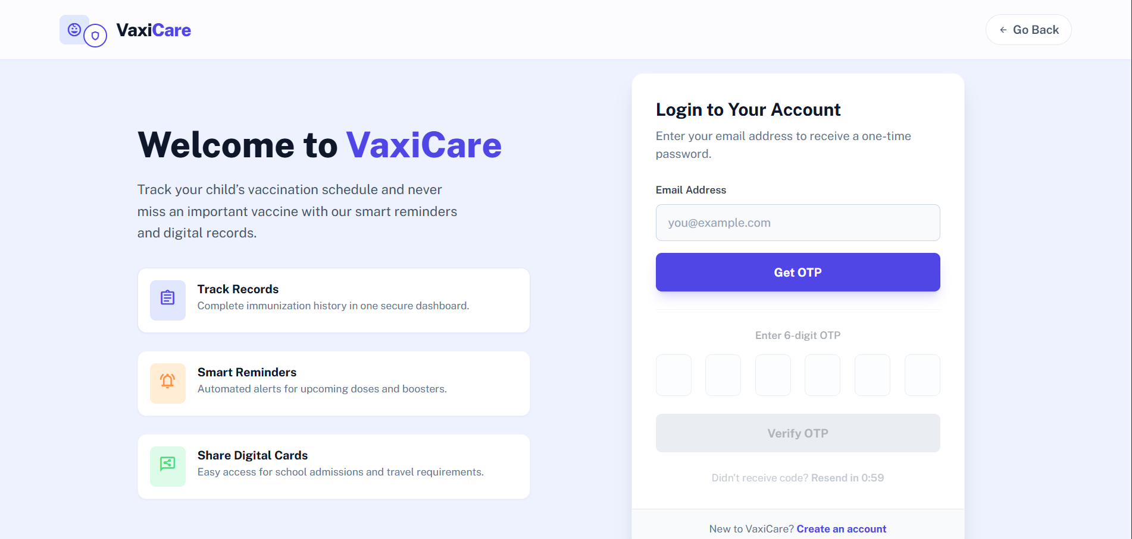

2. User Dashboard
Once logged in, parents are directed to a personalized dashboard, while admins have oversight of all user activities.
• Parent Dashboard: This view utilizes real-time database data to display active vaccination progress. It features due-notification logic, which triggers high-visibility alerts if the scheduler identifies an upcoming or missed vaccine. • Admin Management: The admin dashboard provides a centralized view of user activity, system awareness, and record consistency.
The parent dashboard provides a comprehensive view of a child’s active vaccination lifecycle and serves as the primary interface for the scheduling engine and notification logic. This dashboard utilizes real-time data from the vaccine record collection to calculate and display time-sensitive status indicators, such as “7 days remaining,” “Due Tomorrow,” or “Overdue.” The most critical functional achievement shown here is the reminder notification system, which triggers an immediate high-visibility alert banner when the system’s background scheduler identifies an approaching or missed due date. The interface dynamically renders individual vaccine cards, illustrating the automated tracking of statuses while providing clear actions such as “Mark Done,” “Reschedule,” or “View Info” to empower the parent to act without requiring repeated external clarification. By integrating these proactive alerts directly into the personal user workspace, the system effectively transitions from a passive record keeper to an active healthcare support tool that encourages timely action and reduces missed vaccinations.

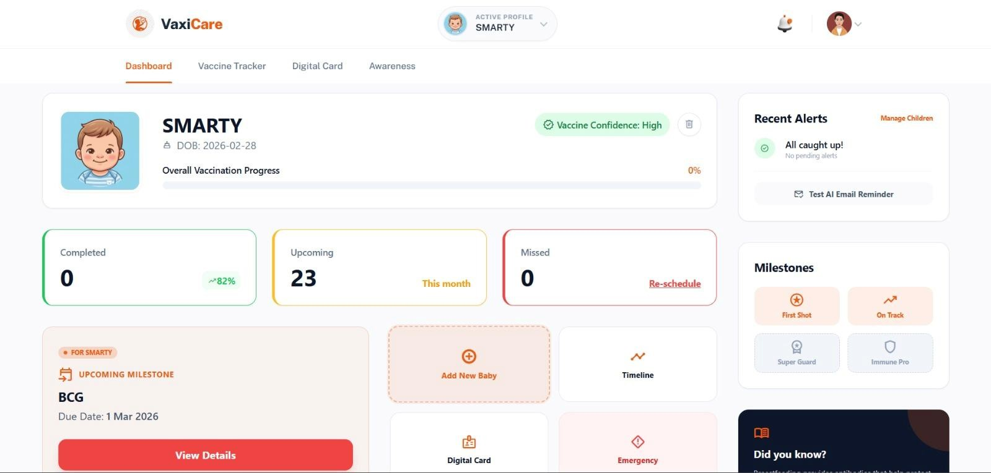

Fig 4.2 User Dashboard

3. Admin Dashboard
The admin management portal provides a centralized interface for high-level oversight of user activity, record integrity, and system support across the parent population. This administrative view displays the aggregated results of the scheduling engine by surfacing the real-time due and overdue statuses for vaccine tracking. The system enables administrators to maintain institutional or application integrity through a suite of management actions, including the ability to review child records, inspect reminder performance, and monitor health tracking consistency. By surfacing these background calculations in a streamlined table or dashboard format, the interface allows for rapid identification of pending support cases and facilitates efficient management of the application ecosystem, ensuring that the system remains balanced between automated background processing and necessary human-in-the-loop interventions.

4. Adding New Child / Vaccine Record
When users add new child records, the system employs proactive schedule generation to prevent confusion. • Automatic Schedule Creation: By inputting the child’s date of birth and clicking save, the system initiates the schedule-generation process.
• Record Validation: The logic compares the generated timeline against the child’s age and required entries. If discrepancies exist, missing or incomplete fields are highlighted, requiring correction before the data is saved to the database.
The “Add Child Profile” interface serves as the primary data ingestion portal where the schedule-generation logic and record validation are initialized. This interface allows the system to bridge the gap between manual parental entry and a verified immunization timeline. By inputting the child’s basic details, the backend executes timeline generation to populate vaccine stages such as name, due period, and status, which are then reconciled against the child’s profile to prevent confusion. Furthermore, the vaccine assignment module demonstrates integration with the tracking algorithm, offering structured mapping of due stages that correspond directly to the child’s age and schedule record in the database. This workflow ensures that every new child added to the system is immediately ready for real-time dashboard tracking, maintaining a seamless digital twin of the immunization journey.

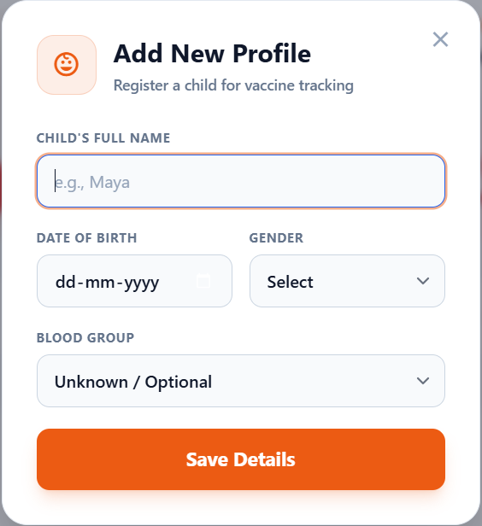

Fig 4.4 : Adding Child

5. Parent Interface Live Schedule
The final step in the user journey is identifying the current and upcoming vaccines using the vaccine tracking algorithm. • Interactive Timeline: Users view a structured top-down vaccine schedule rendered via the frontend presentation layer.
• Precision Tracking: Upon selecting a vaccine, the system fetches schedule data from the database and triggers a high-visibility status highlight on the exact vaccine card. This smartcalendar-like experience eliminates cognitive friction within vaccination planning.
The live vaccine timeline interface represents the successful implementation of the schedule mapping algorithm, serving as the functional bridge between digital records and real-world vaccination action. By fetching real-time due dates and statuses from the data tier, the presentation layer renders a dashboard-style visualization that eliminates the recordawareness gap prevalent in traditional systems. The algorithm precisely identifies the target vaccine and triggers a visual status indicator to provide the user with an intuitive, smart-alertlike experience. Simultaneously, the interface integrates essential metadata such as vaccine name, description, disease prevented, and live completion state, while the “Mark as Done” action seamlessly initiates the status update logic to begin tracking the next stage in the immunization lifecycle.

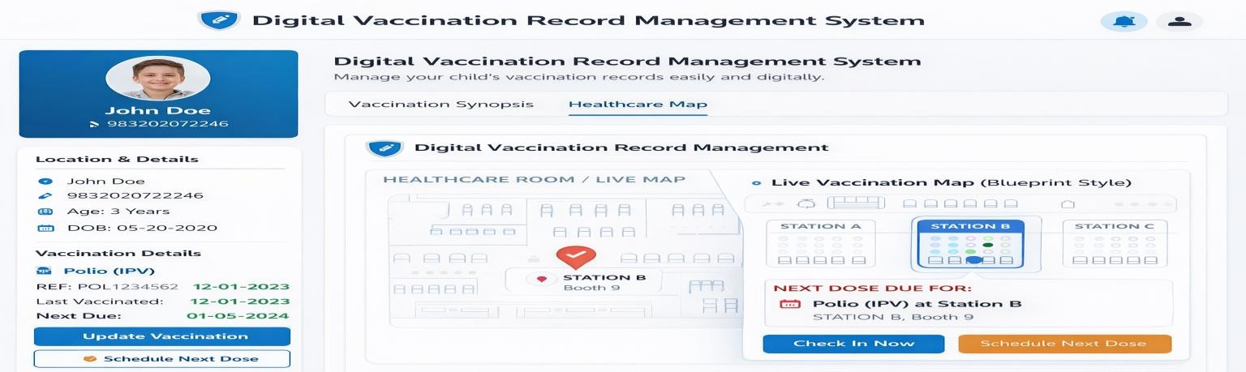

Fig 4.5 User Interface Live Map

6. Record and Timeline Management
To maintain the digital vaccination record, authorized users use the management tools to update data and statuses. • Dynamic Configuration: Parents or administrators can define or update vaccine completion statuses and due conditions directly from the dashboard. • Real-Time Sync: Because the tracking is date-based, any changes made here are instantly propagated to the parent-facing timeline without requiring code updates.
The management interface serves as the central administrative workspace for maintaining the child’s physical-to-digital vaccination progression, allowing for real-time manipulation of the schedule mapping logic. This panel provides a high-level overview where authorized users can define child details, set completion dates, and adjust status information directly through the dashboard. The interface features status indicators to visualize the live condition of individual vaccine stages, directly reflecting the current state of the database. By enabling features like status editing and action-based updates, the system ensures that the timeline data used for parent navigation is both accurate and easily maintainable without requiring backend code modifications.

4.4 Conclusion
The development of the Digital Vaccination Record Management System represents a successful endeavor to modernize child immunization tracking through the application of a modern full-stack architecture. By transforming the traditional vaccination process from a static paper-based record into a dynamic, parent-centric digital ecosystem, this project has effectively addressed the long-standing record-awareness gap. The transition from a textheavy, reactive interface to an interactive, visual, and proactive platform ensures that the system is not just a storage tool, but a functional asset that optimizes the day-to-day tracking activities of both parents and administrators.
In final analysis, this project demonstrates that modern web technologies are uniquely suited for handling the fluid and real-time demands of child vaccination monitoring. The resulting system is scalable, secure, and highly responsive, providing a blueprint for how healthcare support platforms can leverage full-stack development to bridge the gap between digital records and real-life health action. provides a solid foundation for future enhancements such as integration with hospital platforms and advanced predictive health reminders, ensuring the vaccination support ecosystem remains aligned with technological evolution.

5. Conclusion and Future Work

5.1 Conclusion

The Digital Vaccination Record Management System stands as a cornerstone in the modernization of child immunization tracking, serving as a powerful tool to streamline record management, enhance parent experience, and facilitate timely access to vaccination information. Despite its undeniable advantages, including efficient schedule generation, reminder management, and record visibility, the system is not without its limitations.
Looking ahead, the future of digital vaccination systems holds promise with the integration of emerging technologies like artificial intelligence, IoT, and augmented reality, paving the way for innovative solutions to further enhance child healthcare support and adapt to evolving user expectations. In essence, while mindful of its limitations, the Digital Vaccination Record Management System remains a fundamental asset in the preservation and accessibility of health-related information, empowering families to fulfill timely immunization responsibilities in an ever-changing digital age. Through continued innovation, collaboration, and commitment to excellence, the system will continue to evolve, enriching the lives of parents and contributing to the advancement of preventive healthcare as a whole.
The Digital Vaccination Record Management System successfully addresses the recordawareness gap that has historically limited the efficiency of child immunization tracking. By moving beyond traditional paper-based and static digital records and implementing a proactive, full-stack architecture, the project provides a seamless digital twin of the child’s vaccination journey. The successful integration of the vaccine schedule mapping logic allows parents to transition instantly from a digital reminder to a real-world health action, reducing time-wastage and confusion. Furthermore, the administrative burden is significantly reduced through automated reminder scheduling and catch-up logic, ensuring that records remain high-integrity while the system autonomously manages due dates and notifications without constant human intervention.
From a technical perspective, the project demonstrates the robustness of the chosen technology ecosystem in handling high-concurrency, real-time data synchronization. The use of a decoupled architecture—where the frontend manages complex visual rendering and the backend handles automated scheduler tasks—ensures high performance and scalability. The implementation of secure authentication and asynchronous reminder mechanisms further solidifies the system’s reliability as a professional-grade engineering solution. Ultimately, this system serves as a scalable foundation for future enhancements like IoTenabled health integration and AI-based reminder intelligence, proving that modern web technologies can fundamentally transform traditional health record practices into proactive, intelligent environments.

5.2 Limitations
Despite the successful implementation of the architecture and tracking algorithms, the system has specific engineering boundaries that define its current scope:
- Schedule Dependency: The system’s smart tracking is currently based on predefined vaccination schedules. If national immunization rules change significantly, the schedule dataset must be updated accordingly.
- Manual Status Updates: At present, completion of a vaccine must be marked manually by the parent or authorized user. The system does not yet verify dose completion directly from a clinic or hospital source.
- Limited External Integration: The current version is parent-focused and does not include direct integration with hospital management systems, government immunization portals, or pediatric clinic databases.
- Awareness Dependence: Although the system provides notifications and vaccine information, its effectiveness still depends on the parent responding to reminders in a timely manner.
- Connectivity Reliance: The scheduler-based alerts require an uninterrupted server connection. If the deployment environment faces downtime at the scheduled run time, the notification cycle may experience delays.
To overcome the mentioned limitations, the following features are proposed for future development phases:
- Hospital/Clinic Integration: Integrating the system with pediatric clinics and vaccination centers so that completed doses can be verified automatically from the provider side.
- AI-Based Smart Suggestions: Using machine learning models to analyze missed-dose patterns and suggest the best reminder intensity or follow-up recommendations for each parent.
- Voice-Activated Assistance: Implementing a voice assistant within the parent dashboard, allowing users to ask questions such as “Which vaccine is due next for my child?”
- Multi-Child Analytics: Expanding the current dashboard to compare vaccination progress across multiple children in a family for better parental oversight.
- Offline-to-Online Sync: Enabling temporary offline data capture with synchronization when internet connectivity is restored.

References
- Corneliu Fagarasan, Library Management: An Overview of its Past, Present, and Future, Romanian Journal of Library and Information Science 13(2):47-52, June 2017.

- Norhayati Harum, Norhazifa Harum, Najwan Md Khambari, Library Management System, Volume 3 No.1 2023, August 2023.

- Shanmugam A.P, Ramalakshmi A, Sasthri G, Baalchandran S, December 2020, Library Management System, ISSN no: 1006-7930, 12(11):743-753, December 2020.

- Jayanthi Jaganbabu, Jn Dominic, December 2023, Status and problem of Integrated Library Management system among Engineering College Libraries in Tamil Nadu with Special Reference to Kancheepuram district, 11(9):1907-1911, November 2023.

- Samuel Acheampong, Godfred Ampofo, Xu He, September 2018, Design and Implementation of Library Management System, 182(13):18-25, September 2018.

- Pressman R. S., Software Engineering: A Practitioner’s Approach, McGraw-Hill, 8th Edition, 2014.

- MongoDB Inc., MongoDB Documentation, Available: https://www.mongodb.com/docs/

- Google Developers, Google Books API Documentation, Available:
https://developers.google.com/books

- Node.js Foundation, Node.js Documentation, Available: https://nodejs.org/en/docs/

- React Documentation Team, React.js Official Documentation, Available:
https://react.dev/

